**Chapter 22 - The Roaring Twenties**

**Bull Market** - Characterized by optimism, investor confidence and expectations that strong results will continue; the opposite of a bear market. A bull thrusts its horns up into the air while a bear swipes its paws down. These actions are metaphors for the movement of a market. If the trend is up, it's a bull market. If the trend is down, it's a [bear market](http://www.investopedia.com/terms/b/bullmarket.asp).

**Ponzi Scheme** - A fraudulent investing scam promising high rates of return with little risk to investors. The Ponzi scheme generates returns for older investors by acquiring new investors. When new investments stop, these schemes usually collapse.

**Prohibition** - A 14-year period of U.S. history in which the manufacture, sale and transportation of liquor was made illegal. 18th Amendment ratified in 1919. 21st Amendment repealed in 1933.

**Yellow Dog Contract** - An agreement between an employer and an employee in which the employee agrees, as a condition of employment, not to be a member of a labor union.

<http://www.youtube.com/watch?v=3svvCj4yhYc&feature=related>

Urbanization

“How ya gonna keep ‘em down on the farm after they’ve seen Paree?”

<http://www.bing.com/videos/search?q=How+ya+gonna+keep+%e2%80%98em+down+on+the+farm+after+they%e2%80%99ve+seen+Paree&mid=FB80A5D12CA071539E44FB80A5D12CA071539E44&view=detail&FORM=VIRE5>

The idea that once the soldiers had been off the farm and seen how grand it all was they would not return

Lured by the availability of jobs, excitement of city life, and advance in transportation

Nearly 15 million came to cities between 1920-1930

At the end of WWI 2,500 people in urban centers

By 1920 more than 27 million lived in the urban centers (just more than half the population)!

For the first time in the nation's history, by 1920 over 50 % of the population were urban dwellers.

The large migration of African-Americans from the south to the north during the 1920s was due to employers in the North who had traditionally hired many immigrants had to search elsewhere when immigration restrictions were imposed

In the 1930s 300,000 African Americans lived in the Harlem – which was the center

Harlem Renaissance

Literature and arts flowered, but the backbone was industrial jobs

In the 1920s, American (non-farm) labor benefited from all of the following:

Low unemployment rates (ave 3.3% between 1923-29)

Increased earnings for non-farm (up 23% btwn 1919-1929)

Falling weekly hours (48 hr work week)

Legal limits on immigration.

**Introduction**

* President Warren G. Harding said that American’s hoped for a “return to normalcy”
* Post WWI, desire to return to normalcy, return to laissez-faire
* In general the economy was allowed to use market forces
* Taxes were cut back
* Wartime controls & nationalization of railroads ended
* Pres. Harding encouraged mass consumption, mass production, and giant corporations which became the trademark of the 1920s
* Middle-class lifestyle emerged and automobiles were used more and more
* Brief recession 1920 – 1921
* *Spectacular growth* during most of the remainder of decade

**Social Changes After WWI**

* Increased Urbanization – 1920 Census over 50% of population lived in cities of more 2,500
  + - Blacks led the urban migration away from South
* End of free immigration & the labor it provided
* 18th Amendment – Prohibition against alcohol (1919)
* Fear and hate caused the rise of the Ku Klux Klan, anti-African American, anti-Jewish, and anti-Roman Catholic persecutions had become a national scandal
* The roles of women in the 1920s

Women gained the right to vote via a Constitutional Amendment

- Universal Suffrage - In August 1920, ratification of 19th Amendment Right To Vote for Women

There was an increase in educational opportunities for women.

Women gained a significant amount of cultural and social freedom.

Women gained work Opportunities - But not two-income families

1920 flapper – women became more socially equal – they could smoke men’s cigarettes, drink men’s whiskey, and play men’s games

"Marriage bars"

Became more widespread in the 1920s

Forced female employees to leave work when they married.

**New Goods & Rise of Middle Class**

* Modern standard of living became broadly available to middle class
* Major source of economic growth in the 1920s

Construction of residential housing

Production of consumer durables

Automobile production

* There was a significant increase in mass production, mass marketing, and advertising
* Huge advances in the production of consumer durables, electric power, new appliances, and suburban housing

|  |  |  |
| --- | --- | --- |
|  | 1920 | 1930 |
| Inside flush toilets | 20% | 51% |
| Central heating | 1 | 42 |
| Home lighting with electricity | 35 | 68 |
| Mechanical refrigerators | ** | 8 |
| Washing machines | 8 | 24 |
| Vacuum cleaners | 9 | 30 |
| Radios | ** | 40 |
| Automobiles | 26 | 60 |
| ** less than 1% |  |  |

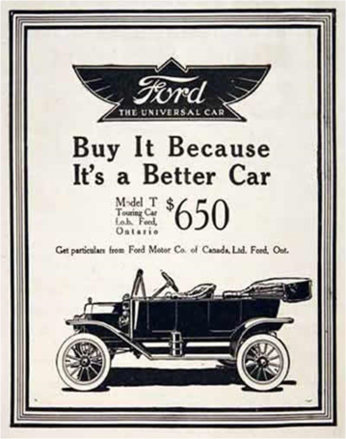

**Automobiles**

* Became the economic symbol to the 1920s
* Production went from 1.5 million cars in 1921 to 4.8 million in 1929
* Created a great construction boom and enlarged the demand for government paved roads
* Automobiles changed society:
  + People moved to suburbs
  + Paved highways – increased greater mobility
  + Food, lodging, gas stations
* Federal Rural Road Act of 1916
* 1921 Federal Highway Act

**Buy Now, Pay Later – Consumer Credit**

* Consumer credit policies were developed and instituted on a large scale for the first time.
* Consumer credit – “buy now, pay later”

- The rapid increases in income reduced the use of credit

* Increased ownership of consumer durables – *Refrigerators, Washers, Toasters, Radios, etc.*
* Mass production like Henry Ford’s Model T assembly lines made these items affordable
  + Down payment & installments thereafter
  + Auto industry formed finance companies like GM’s GMAC

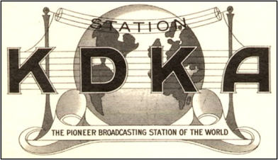 **Advertising** (print & radio) became a $1 billion industry by 1920

The ownership of radios increased from less than one percent in 1920 to 40 percent in 1930.

Radio transformed culture and political life

Radio captured Americans’ imagination – **KDKA** in Pittsburgh (1920)

National Broadcasting Company (NBC) formed in 1926

Columbia Broadcasting System (CBS) formed in 1927

Advertising continued to spur on consumer spending

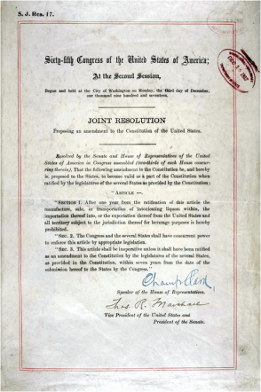 Mostly in newspapers and magazines (especially aimed at women – *Ladies Home Journal*)

Touted the benefits of the new lifestyle based on time and labor-saving consumer durables

**Prohibition – A *“Noble Experiment?”***

Eighteenth Amendment – Prohibition of 1917

Prohibited the manufacturing, sale, or transportation of “intoxicating liquors”

Took away the comfort of field hands, factory workers, and others on the grounds that drinking was sinful and that poor people were not entitled to such a luxury anyway

Originated as temporary measure in WWI

Seen as war effort – freed up resources in the brewing and distilling industries and kept workers at peak efficiency

Volstead Act of 1919

Tightened enforcement

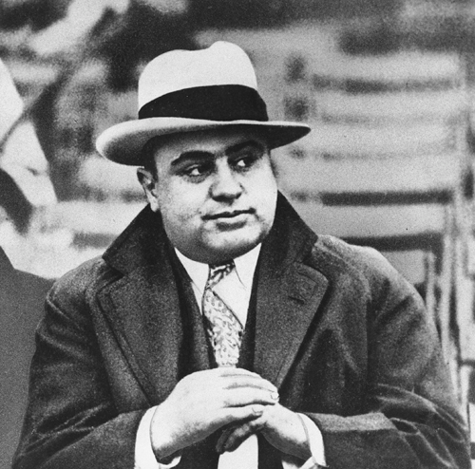During Prohibition the consumption of alcohol fell, crime rate increased, and the amount spent on law enforcement more than doubled from $6.3 million in 1921 to $13.4 million in 1930.

Rise of organized crime gangsters like Al Capone

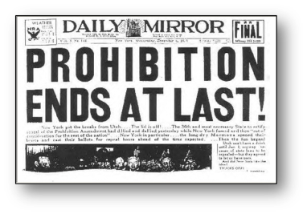 Bootlegging became a major industry, and gangs such as Al Capone and Legs Diamond became household names

21st Amendment repealed prohibition in 1933

**Paycheck Rises**

* 48-hour work week became standard by end of 1920s
* More leisure time

*Al Capone*

* Low unemployment in most of 1920s
* Increased real earnings (inflation adjusted) of non-farm workers:

|  |  |
| --- | --- |
| **1919 – 1929** | **1914 - 1929** |
| **23%** | **33%** |

**Unions Decline**

Declining labor unions during the 1920s

Increase in real wages – labor was generally satisfied

The American Federation of Labor (AFL) took no interest in organizing the growing mass production industries

The growth of the service sector.

Increased use of high-tech, labor-saving devices in the manufacturing sector.

Injunction – temporarily a court forbid practices like picketing, secondary boycotts and the feeding of strikers by the union

Firms’ use of *“yellow-dog contracts”* – new employees promised not to join a union, to prevent union membership, and to serve as a basis of civil suits against unions that persuaded employees to violate the contracts

Poor union leadership.

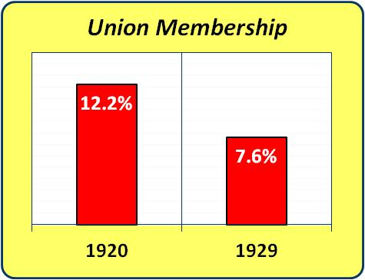

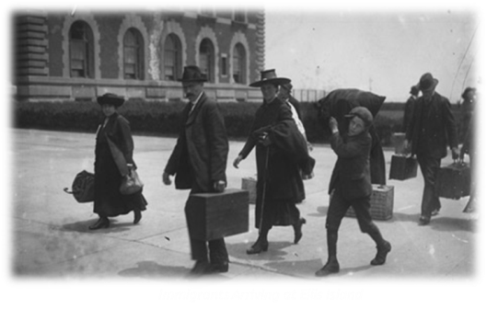 **Immigration Restricted**

* From 1882 forward, attempts to limit immigration
* Immigration was restricted because of the fear that America would be flooded by immigrants fleeing the war devastated economies of central and eastern Europe
* Between 1880 and 1920 the following were used to limit the number of immigrants

1882 Chinese immigration was banned for 10 years

Immigrants Arriving at Ellis Island

In 1885 the practice of prepaying the cost of an immigrant’s voyage in exchange for future labor services outlawed

Implementing a financial test for potential immigrants in 1907

Utilizing a literacy test for potential immigrants in 1917

* 1920s - End of free immigration

**The Emergency Immigration Acts of 1921 & 1924**

* Congress restricted immigration to 3% of the number of people of that nationality residing in the US in 1910
* Placed limits on immigration based upon percents of Americans of a particular nationality/heritage
* In 1924 a new law set it at 2% of those here in 1890
* Organizations like the Ku Klux Klan, Unionized labor, and the South supported restrictions on immigration
* East Asian immigration eliminated
* Restricted Southern & Eastern Europeans
  + Fear large groups of unskilled workers escaping Europe after WWI to compete with American workers
  + Racism
  + Fear of Revolutionaries & Communists

Immigration, 1910–1929

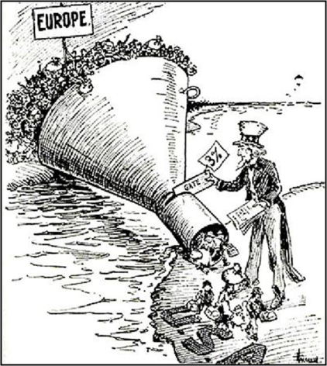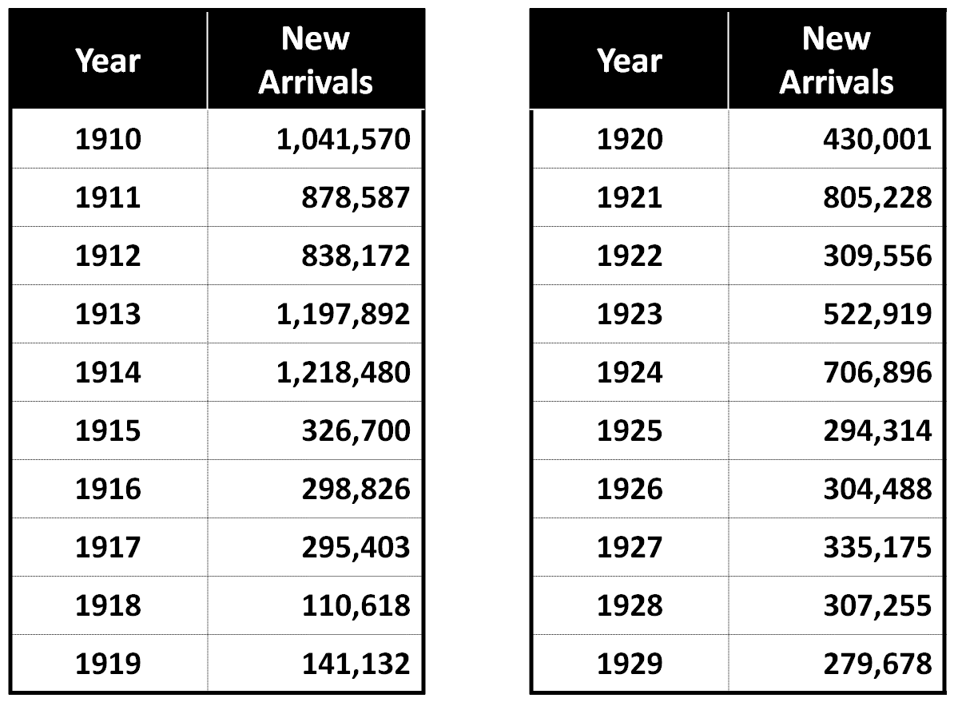

**Labor Force in the 20’s**

America goes to High School

* Graduation became a rite of passage from childhood to adulthood
* US had a higher graduation rate compared to the rest of the industrialized world
* High school graduates earned higher wages than non-graduates
* Pushed by rural areas so as to give more economic and social opportunities
* Communities with high school cohesion tended to support public high schools especially in Midwest (IA & NE)
* High school became every similar to today – 45 min periods, diverse curricula, grades, bands, and athletic teams
* From 1920 – 1938, graduation % of 17-year old went from 16.2% to 48.2%

|  |  |  |
| --- | --- | --- |
| **High School Graduation Rates (**as a percentage of children age 17) | | |
| **Year** | **48 States** | **32 Non-Southern States** |
| 1910 | 8.6% | 11.1% |
| 1920 | 16.2 | 19.9 |
| 1928 | 27.0 | 32.1 |
| 1938 | 48.2 | 55.9 |

**On the Land - Agriculture**

“Golden Age of Agriculture” 1896-1914

Rapid improvement in the economic position of the American farmer

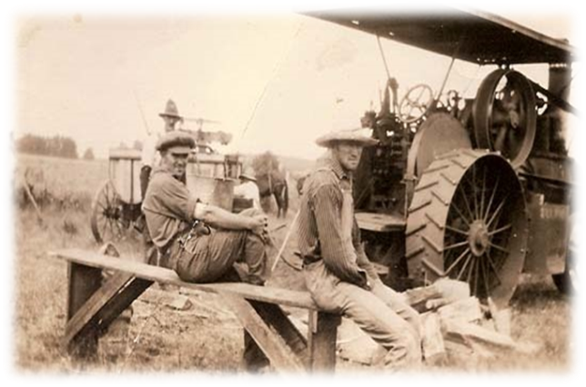Farm incomes had risen during WWI

During 1910-1920 land boom, Midwest farmers borrowed

1920s were hard times for farmers

1ST steps by the government towards the support of farm incomes

The deflation of 1920-21 was felt the most in agriculture

Borrowers are hurt by deflation & farm borrowers had mortgages foreclosed

Index

From 235 in June 1920 to 112 a year later 🡪 a slight recovery to 159 in Aug 1925 🡪 fell a bit

1920’s farm workers

Very debt burdened

The land had increased in value ($500 per acre) and people had bought at the wrong time

Long term debt went from $3.2 billion in 1910 to $8.4 billion in 1920 to nearly $11 billion in 1922

Foreclosures increased from 2.8 per 1,000 mortgaged homes in 1918 to

3.8 in 1920

6.4 in 1921

11.2 in 1922

14-17 for the remainder of the 1920s

“Equality for Agriculture”

Argued that agriculture was entitled to its fair share of national income and that this would be achieved if the ratio of the prices farmers received to the prices they paid was kept equal to the ratio that had prevailed from 1910-1914

McNary-Haugen bills

2 methods

1. Tariff was to protect the home market from imports
2. A private corporation chartered by the federal government was to buy a sufficient amount of each commodity to force its price up to the computed fair value

Passed by congress 2x and vetoed by Pres. Coolidge 2x

Bottom 2 paragraphs pg 406

**Federal Farm Subsidies**

* 1920-21 War Finance Corp. made loans to farmers -***“Price Parity”***
* *Capper-Volstead Act (1922)* - Exempted farm co-ops from antitrust
* *Agriculture Marketing Act (1929)* - Encourage co-op marketing associations & a stabilization corporation to support prices
* WWI experience with farm price controls convinced farmers it was needed for farmers to succeed
* Federal measures of limited help to farmers

**Rich Get Richer, Poor Get Poorer?**

* Richest Americans’ (Top 1%) share of disposable income rose from 11.8% in 1920 to 18.9% in 1929
* Williamson & Lindert concluded (in 1981) that incomes were not equal in 1929 but it wasn’t drastic or unexpected leading to Great Depression
* Overall, with exceptions, there were substantial improvements in Americans’ standard of living in 1920s

**Macroeconomic Policies**

* Conservative fiscal and monetary policies during the 1920s

Tax rates were cut

Budget was balanced

Federal Reserve focused on restraining economic growth at the end of the 20s

In the 1920s, the Federal Reserve followed a policy of letting insolvent banks fail because it believed that the insolvent banks were too small to be profitable and were badly managed

The 1920s were characterized by large numbers of bank failures each year, especially among country banks. Country banks were particularly inclined to fail because farm mortgages constituted the major portion of their loans

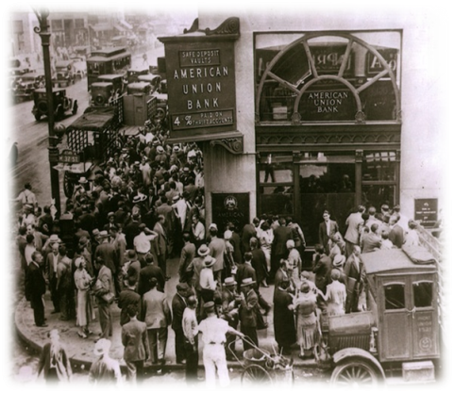 - this policy continued into the 1930s when healthy banks were going under which contributed to the depth of the depression

* 1921 - Federal budget first introduced
* 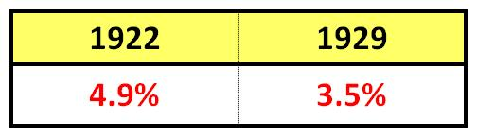Federal spending fell as % of GNP
* In 1924, 1926 & 1928, Congress:
  + Eliminated excise taxes
  + Reduced tax rates on personal & business taxes
  + Lowered estate taxes
* **Fiscal Policy** = Taxing & Spending of Federal Government
* Federal revenues grew
* **Monetary Policy** = Money Supply - Controlled by Federal Reserve
* Economy grew & money supply rose but prices were stable

Bank customers line up outside their failed bank

* Large number of mainly rural banks failures – Fed thought they should fail because poorly managed
* Bank failures caused by state prohibitions on branch banking
* Fed worried about speculation on Wall St. but didn’t know how to react

**International Developments**

* Under *Treaty of Versailles*, Germany required to pay war reparations:
  + Germany couldn’t make payments
  + German Mark inflated to gigantic scale = **Hyperinflation**
* Return to Gold Standard in 1924
  + British Pound Sterling overvalued making British goods expensive in int’l trade & hurt British economy

The Great Bull Market

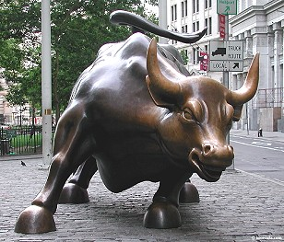 The stock market surged

**Causes of Bull Market**

* + Expectations that high earnings would persist because of technology
  + Stocks bought on margin or borrowing
  + Stock Market Bubble - Investors had bid up prices to unrealistic values

Between 1922 and 1929 stock prices increased by more than 3x or 200%.

((is-was)/was)*100=%

((300-100)/100) *100 = 200% increase

The rise in earnings reflected the great demand – especially in consumer durables and the automobile

During the stock market boom of the late 1920s stock prices rose faster than dividends

Was a belief that the market would keep on booming and provide an ever-higher standard of living for the average American and eventually eliminate poverty and the stock market reflected this optimism

Stock Market was widely followed but not as widely invested in as commonly believed

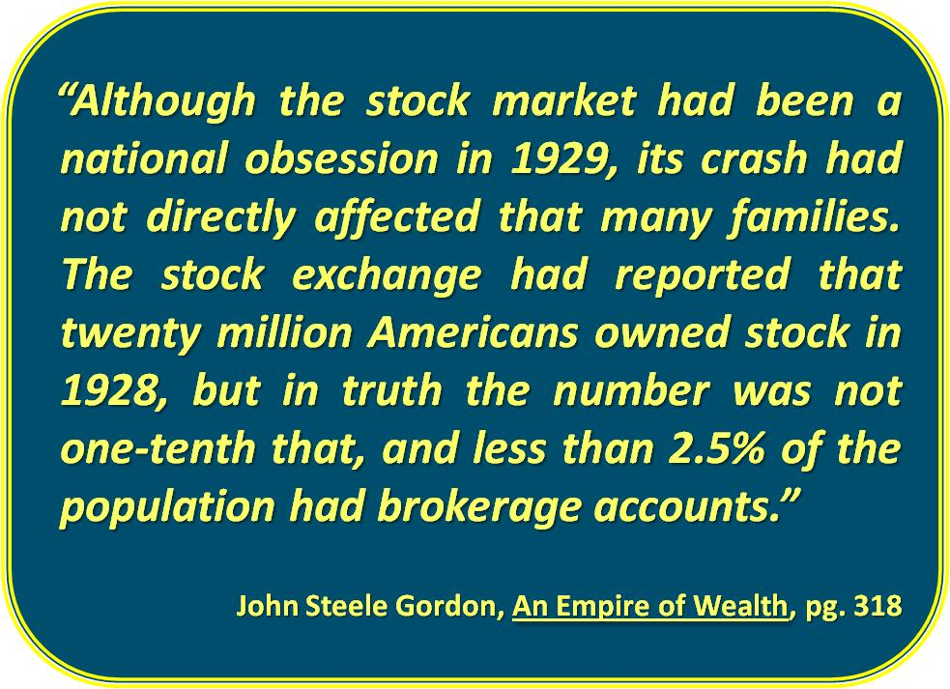

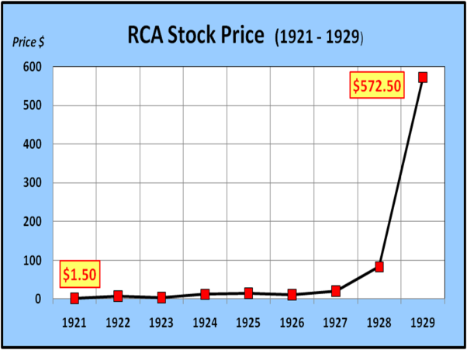**Investing in GM**

⮞ In 1921, purchased $10k in GM stock.

⮞ In 1929, sold GM stock.

⮞ How much did you sell your stock for?

Answer: _____________________

*\*\* In 8 years, GM grew at a rate of 77.83% per year or 9,900% total.*

**Investing in RCA**

⮞ In 1921, purchased $10k of RCA stock at $1.50 per share.

⮞ In 1929, sold RCA stock at $572.50 per share.

⮞ How much did you sell your stock for?

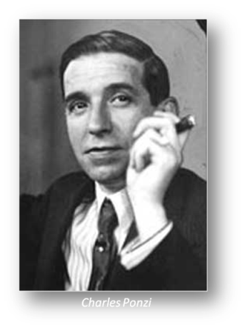Answer: _____________________

*\*\* In 8 years, RCA grew at a rate of over 110% per year or 38,067% total.*

Speculative fever of the 1920’s

The Ponzi scheme and The Florida Land Boom both illustrate the speculative temper of the 1920s

Ponzi Scheme

* + - Money received from new investors used to pay earlier investors
    - Unusually outrageous rates of return promised
      * 50% return in 45 days
      * 330% APY
      * $100 investment = $2,681 in 1 year

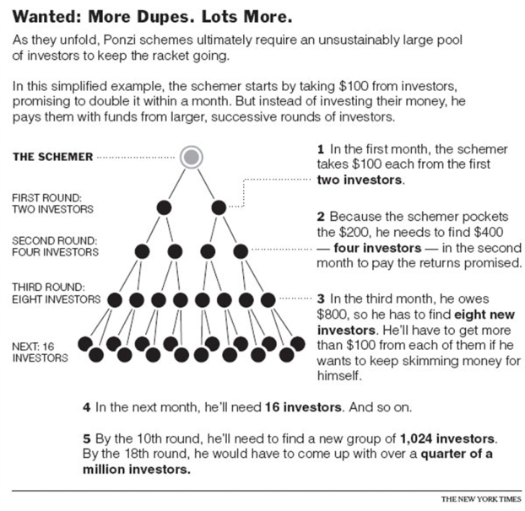Born in Italy, he became known in the early 1920s as a swindler in North America for his money making scheme. Charles Ponzi promised clients a 50% profit within 45 days, or 100% profit within 90 days, by buying discounted postal reply coupons in other countries and redeeming them at face value in the United States as a form of arbitrage. In reality, Ponzi was paying early investors using the investments of later investors. This type of scheme is now known as a "Ponzi scheme". Ponzi was probably inspired by the scheme of William F. Miller, a Brooklyn bookkeeper who in 1899 used the same scheme to take in $1 million

Florida Land Boom

* + Nationwide Real Estate boom or run-up in land values
  + Florida was the most extreme
  + The Marx Brothers’ Movie “Cocoanuts” spoofed the boom
  + 1926 – The Bubble Burst

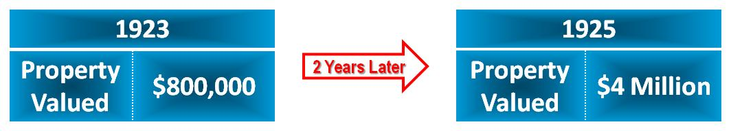

***Recent examples of Ponzi Scheme:***

